#### Configure the Arduino Integrated Development Environment (IDE)

**Table**

1. Install the Arduino Software (IDE) 1

2. Install the CH340 driver 7

Method 1 8

Method 2 11

3. Any questions and suggestions are welcome 13

# Install the Arduino Software (IDE)

The Arduino IDE contains a text editor for writing code, a message area, a text console, a toolbar with buttons for common functions and a series of menus. It connects to the Arduino hardware to upload programs and communicate with them. It is a cross-platform application for Microsoft Windows, macOS, and Linux.

You can visit this link: <https://www.arduino.cc> to install the latest Arduino software (IDE)

The Arduino IDE 2.1.1 is the latest Arduino Software when we write this tutorial.Because the official version will continue to be updated, it is possible that when you see this document and log in to the Arduino official website, the latest version of the Arduino IDE may no longer be 2.1.1, but a higher version. So this document is for you as an example to download the Arduino IDE as a reference.

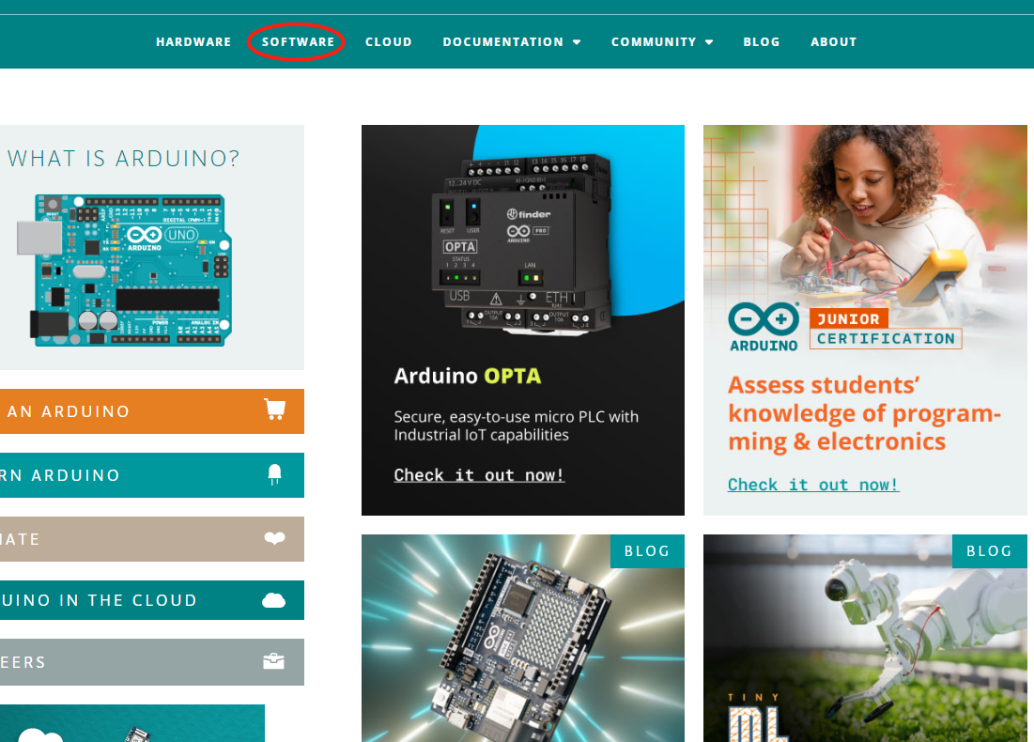

Click the menu bar SOFTWARE on the home page to enter the download interface. Then select and download the corresponding installer according to your operating system.

This document explains how to install the Arduino Software (IDE) on Windows machines. There are three Windows installation version options in the "DOWNLOAD OPTIONS" of the "SOFTWARE" interface.

 Support Win10 and newer 64 bits windows system

 Arduino IDE Windows Installer (.exe)

 Arduino IDE Windows Zip package(Free installation)

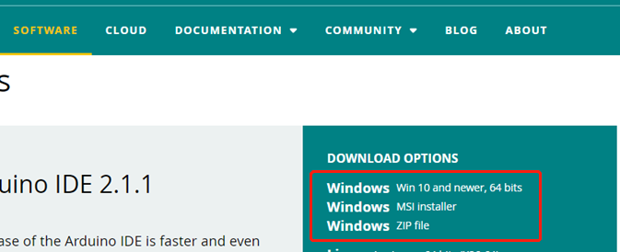

We take the Arduino IDE Windows Zip package(Free installation) as an example, to explain how to use the Arduino Software (IDE) on Windows

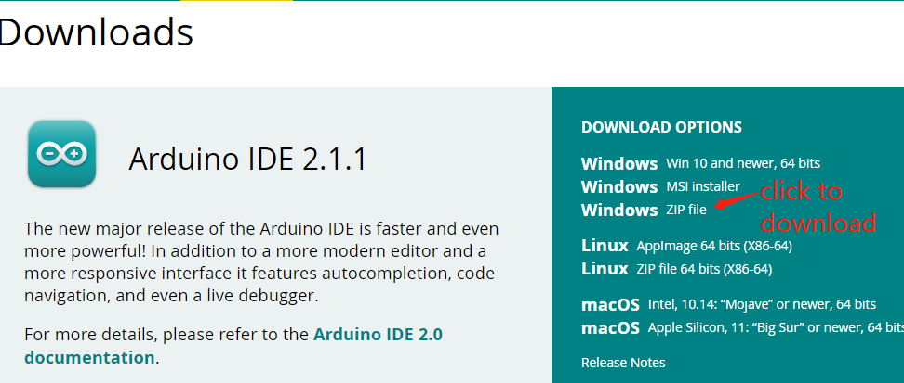

Click to download Windows Zip file

After the download is complete, you will get the compressed package of Arduino IDE 2.1.1.

Unzip it into a folder, open the folder, and double-click the "Arduino IDE" application inside.

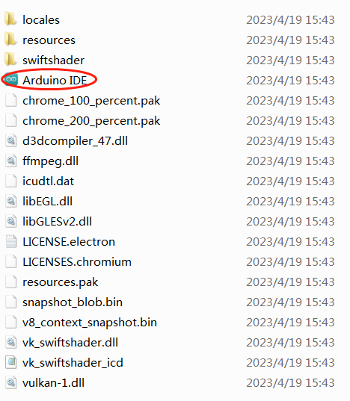

For Windows users, a dialog box prompting "Do you want to install the driver" may pop up during the first run of the IDE software. If it pops up, please allow it to make the driver to be installed.

After the driver installation is complete, a shortcut to the Arduino IDE will be generated on the desktop. Double-click the shortcut to run the Arduino software.

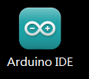

When you run the software for the first time, Arduino will prompt to upgrade the libraries and boards, please click "INSTALL ALL".

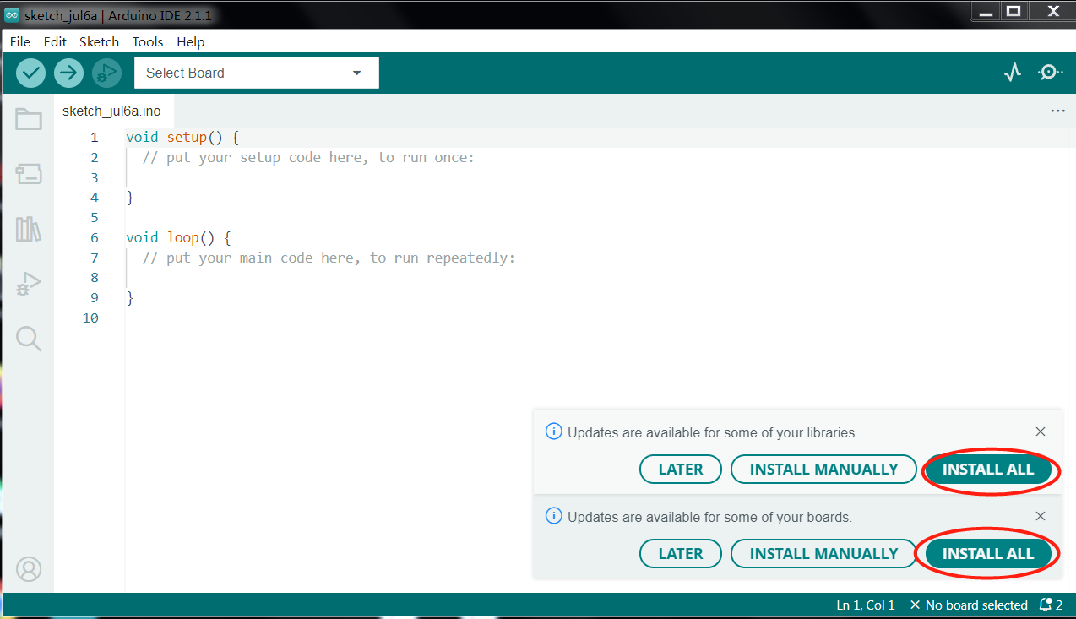

After the libraries and boards are upgraded, the interface of the Arduino software is as follows:

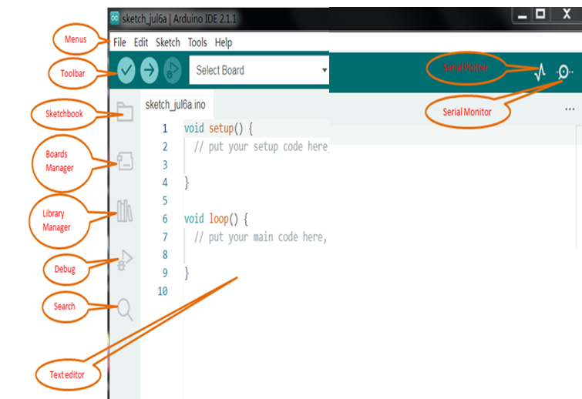

Programs written using Arduino Software (IDE) are called sketches. These sketches are written in the text editor and are saved with the file extension .ino. The editor has features for cutting/pasting and for searching/replacing text. The message area gives feedback while saving and exporting and also displays errors. The console displays text output by the Arduino Software (IDE), including complete error messages and other information. The bottom righthand corner of the window displays the configured board and serial port. The toolbar buttons allow you to verify and upload programs, create, open, and save sketches, and open the serial monitor.

 Verify

Checks your code for errors compiling it.

 Upload

Compiles your code and uploads it to the configured board. See [uploading](https://docs.arduino.cc/software/ide-v1/tutorials/arduino-ide-v1-basics" \l "uploading) below for details.

 Debug

Check for errors in the code (only for some Arduino development boards)

 Boards Manager

You can quickly find the development board you need and install the corresponding package.

 Library Manager

You can quickly query the library you need, and then choose whether to install it or upgrade it according to your needs.

 Serial Monitor

Opens the [serial monitor](https://docs.arduino.cc/software/ide-v1/tutorials/arduino-ide-v1-basics" \l "serial-monitor).

Additional commands are found within the five menus: File, Edit, Sketch, Tools, Help. The menus are context sensitive, which means only those items relevant to the work currently being carried out are available.

# Install the CH340 driver

Most computers have built-in driver or they can install the driver automatically when you first connect the control board of 4wd car to computer. If your computer cannot recognize the control board, please follow this document to install the driver.

# 

**Installing CH340 Driver on Windows**

## Check if the driver is installed

1.Connect your computer and control board of the car with a USB cable.

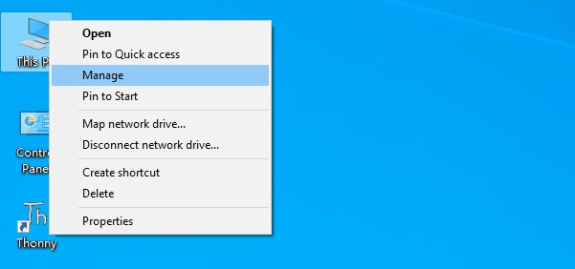2.Go to desktop of your computer, select “This PC” and right-click to select “Manage”.

3.Click “Device Manager”. If your computer has installed the CH340 drive, you can see“USB-SERIAL CH340 (COMx)” in the device manager. This means you don't need to install the driver yourself.

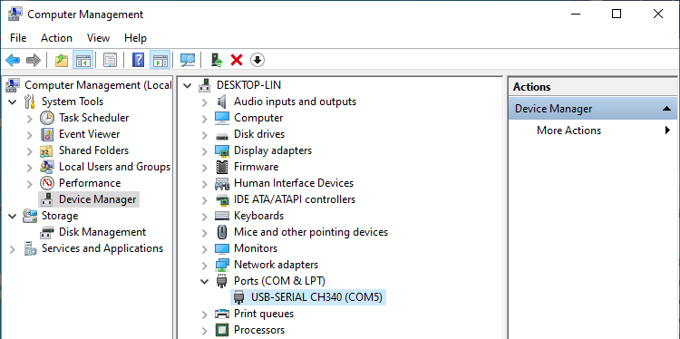

CH340 Port

## Installing Driver

# Method 1

1.If your computer fails to automatically install the CH340 driver, you will not see the your device in the device manager, but "USB Serial" with an exclamation point.

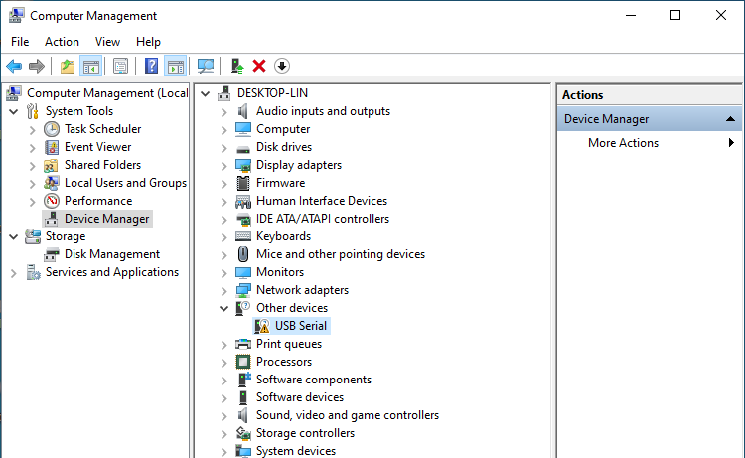

2.Click “USB Serial” and right-click to select “Update driver”.

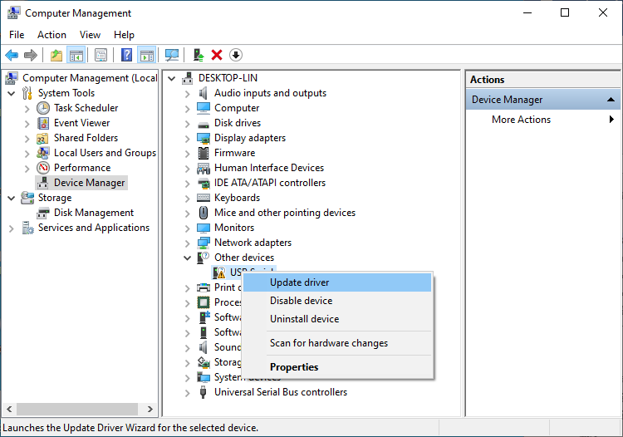

3.Click “Search automatically for updated driver software”.

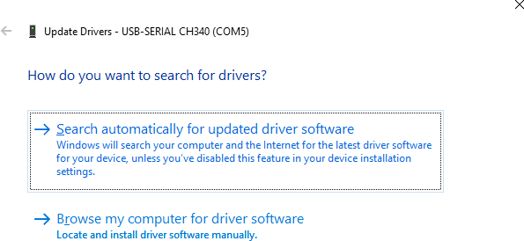

4.Wait for CH340 to finish installation.

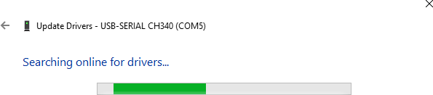

5.When you see the following interface, it indicates that CH340 driver has been installed to your computer. You can close this window.

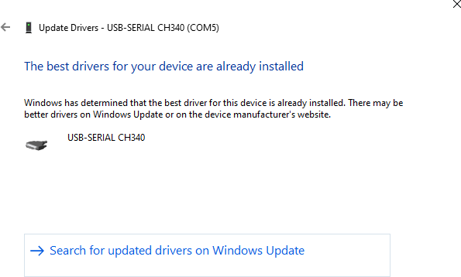

6.If CH340 driver has been installed to your computer, when the control board is connected to your computer, you will see your device name and port number.

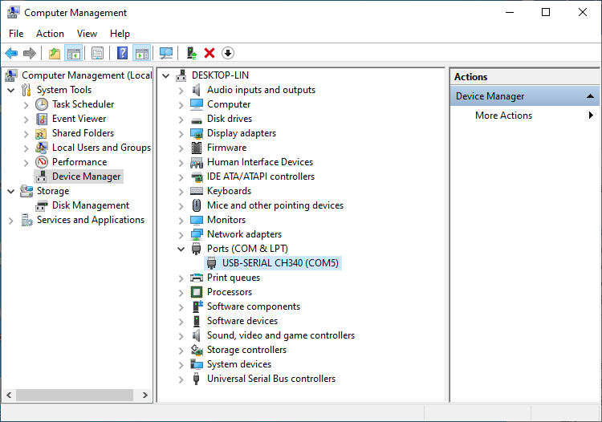

# Method 2

1.First, you need to download CH340 driver,

2.click [http://www.wch-ic.com/search?q=CH340&t=downloads](http://www.wch-ic.com/search?q=CH340&amp;t=downloads) to download the appropriate one based on your operating system.

3.The following figure marks the corresponding drivers for Windows, Linux and Mac computer systems.

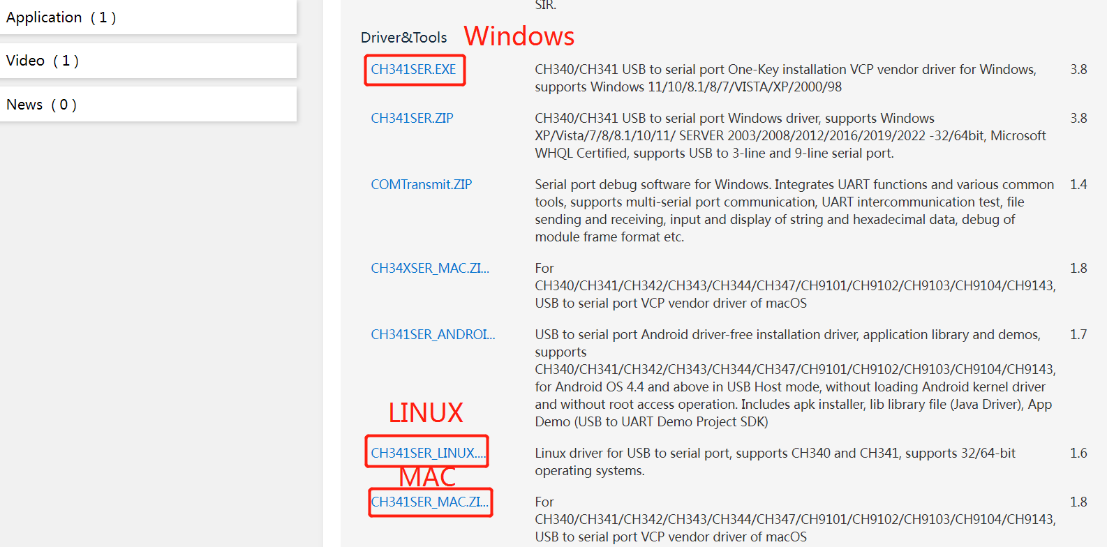

You can also find the installation package in “CH340 Driver” folder which in the “CKK0020-Main”folder you download from the github.



1. Open the folder **“Windows”----“CH341SER”.**

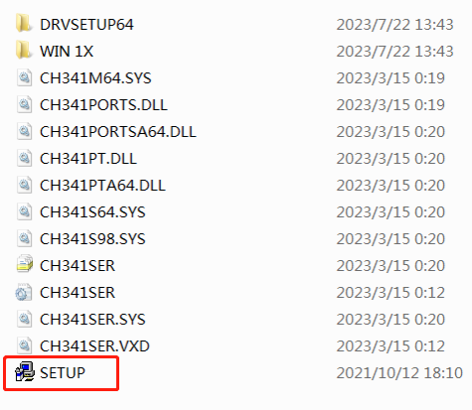

2.Double click “SETUP”.

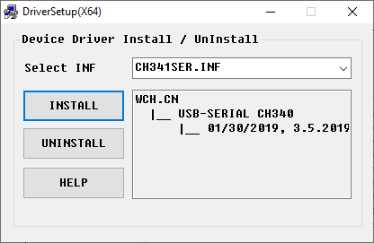

3.Click “INSTALL” and wait for the installation to complete.

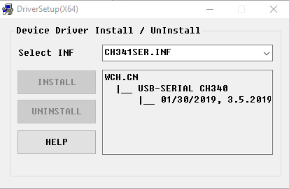

4.Install successfully. Close all windows.

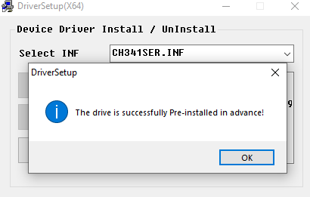

5.When control board is connected to computer, select “This PC”, right-click to select “Manage” and click “Device Manager” in the newly pop-up dialog box, and you can see your device name and port number.



6.So far, CH340 driver has been installed successfully. You can close all dialog boxes.

# Any questions and suggestions are welcome

Thank you for reading this document!

If you find errors, omissions or you have suggestions and/or questions about this document, please feel free to contact us: **[cokoino@outlook.com](mailto:cokoino@outlook.com)**

We will make every effort to make changes and correct errors as soon as feasibly possible and publish a revised version.

If you want to learn more about Arduino, Raspberry Pi, Smart Cars, Robotics and other interesting products in science and technology, please continue to visit our Amazon Store by search for "LK COKOINO" on Amazon. We will continue to launch fun, cost-effective, innovative and exciting products.

Thank you again for choosing Cokoino products.

**LK COKOINO**